AIM

To design and deploy a cloud-based Car Booking Reservation System using Zoho Creator, thereby demonstrating the concept of Software as a Service (SaaS).

Procedure
- Login to Zoho Creator using your Zoho account.
- Create a new application → Select “Create from Scratch.”
- Name the Application: Car Booking System.
  - Design Forms: Car Details Form → Car ID, Car Model, Car Type (Sedan/SUV/Hatchback), Price per Day, Availability (Yes/No).
  - Customer Booking Form → Customer Name, Email, Phone, Car Selection (lookup from Car Details), Booking Date, Return Date.

  - Create Reports: Available Cars Report → Shows all cars with availability status.
  - Booking Report → Displays all reservations with customer details.

  - Add Workflow Automation (Optional): Send booking confirmation email to customer after reservation.
  - Notify admin when a new booking is made.

4.Publish the Application and share the web link with users.

5.Test the Application by making a booking as a customer.

Output

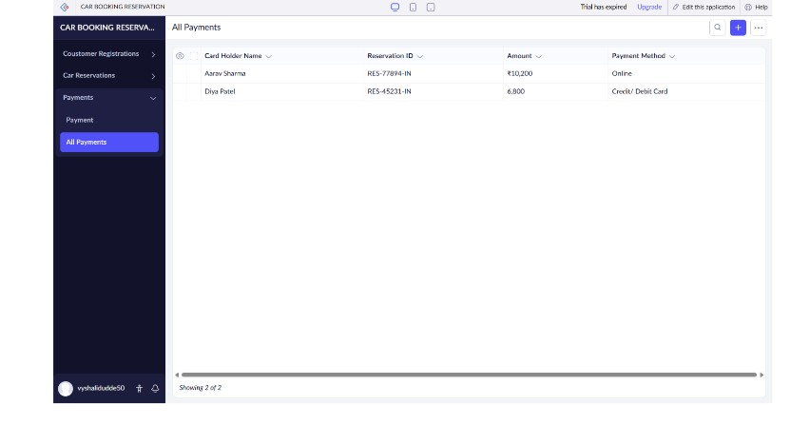
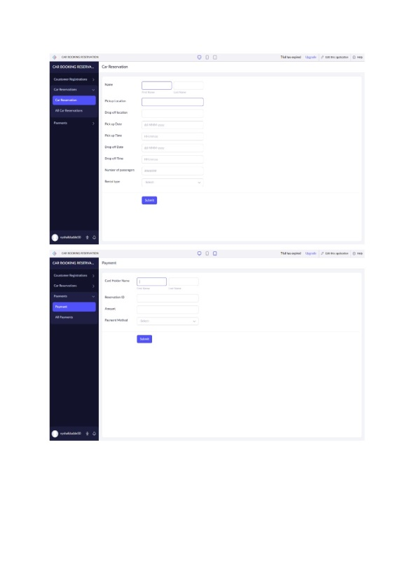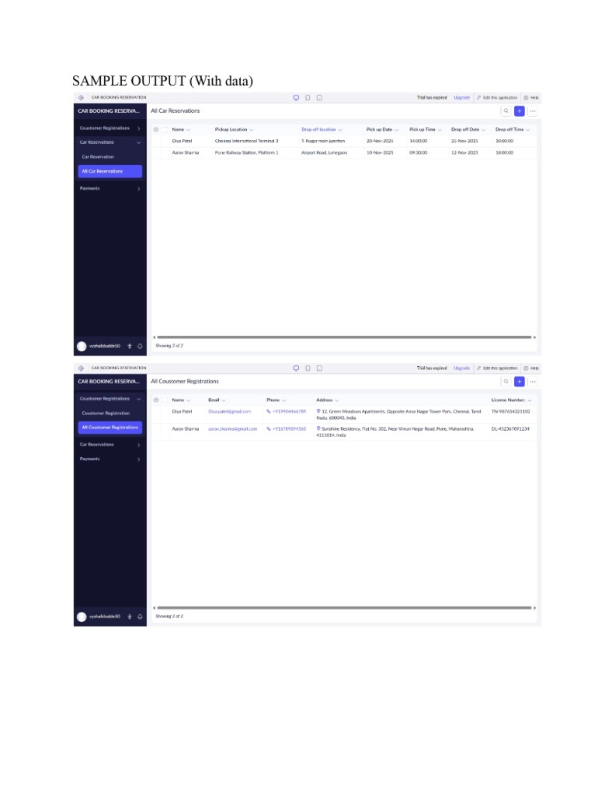

Result
Thus, the Car Booking Reservation System is implemented using Zoho software

